**DNBC – User Guide**

|  |  |  |
| --- | --- | --- |
| **Supervisor** | SIR Muhammad Ikram | |
| **Batch** | 2309E3 | |
| **Group** | **C** | |
| **Serial No.** | **Enrollment Number** | **Student Name** |
| 1. | *Student1512095* | Ahmed |
| 2. | *Student1511010* | Shakir Muhammad |
| 3. | *Student1509187* | Shayan |
| 4. | *Student1510202* | Muzammil Shafiq |
|  |  |  |

# Navbar:

Using the navbar, the user can navigate through various categories. We have total 6 items in Navbar, which are further classified as:

* HOME
* About
* Contact Us
* Business
* Athletes
* Scientists
* Movies & Tv Shows
* Musicians & Singers

**BIOGRAPHY HOME**

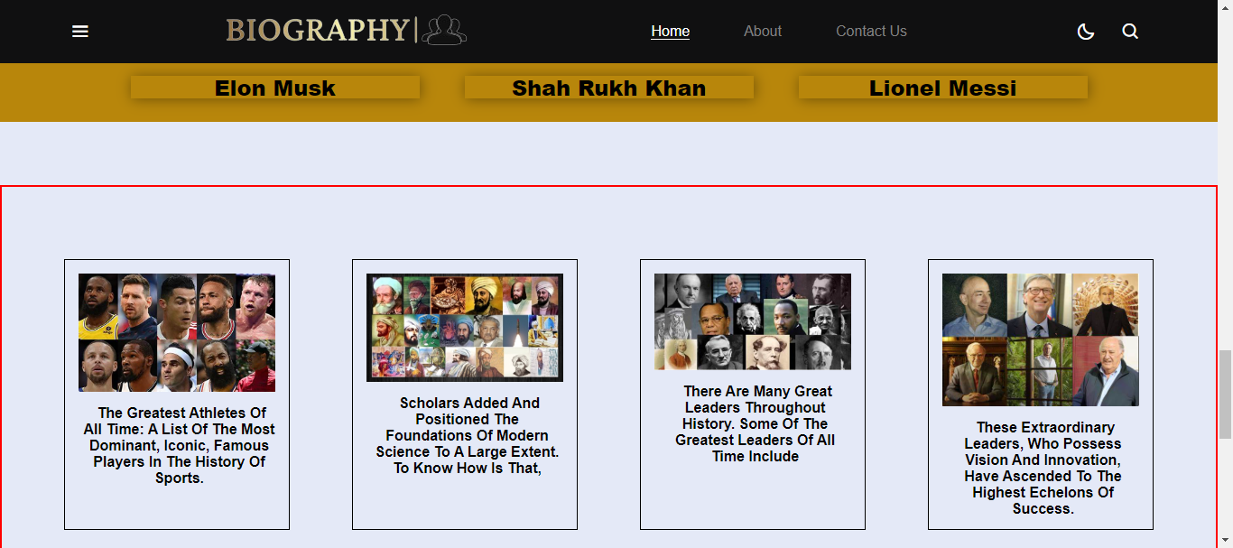**Biography tells you about greatest Athletes, Leaders and Scholars**

**Biography Footer**

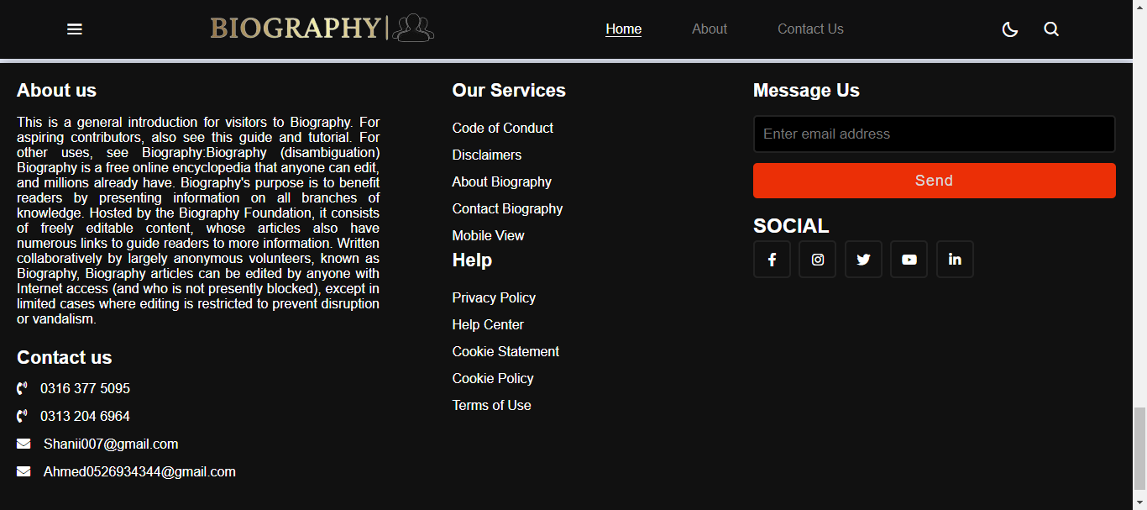

Biography-Athletes

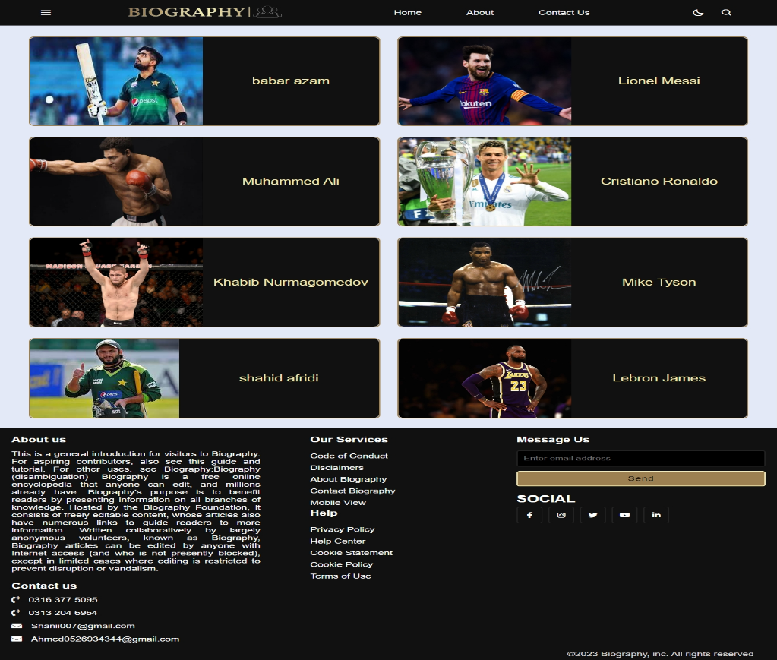

Biography – Contact US

